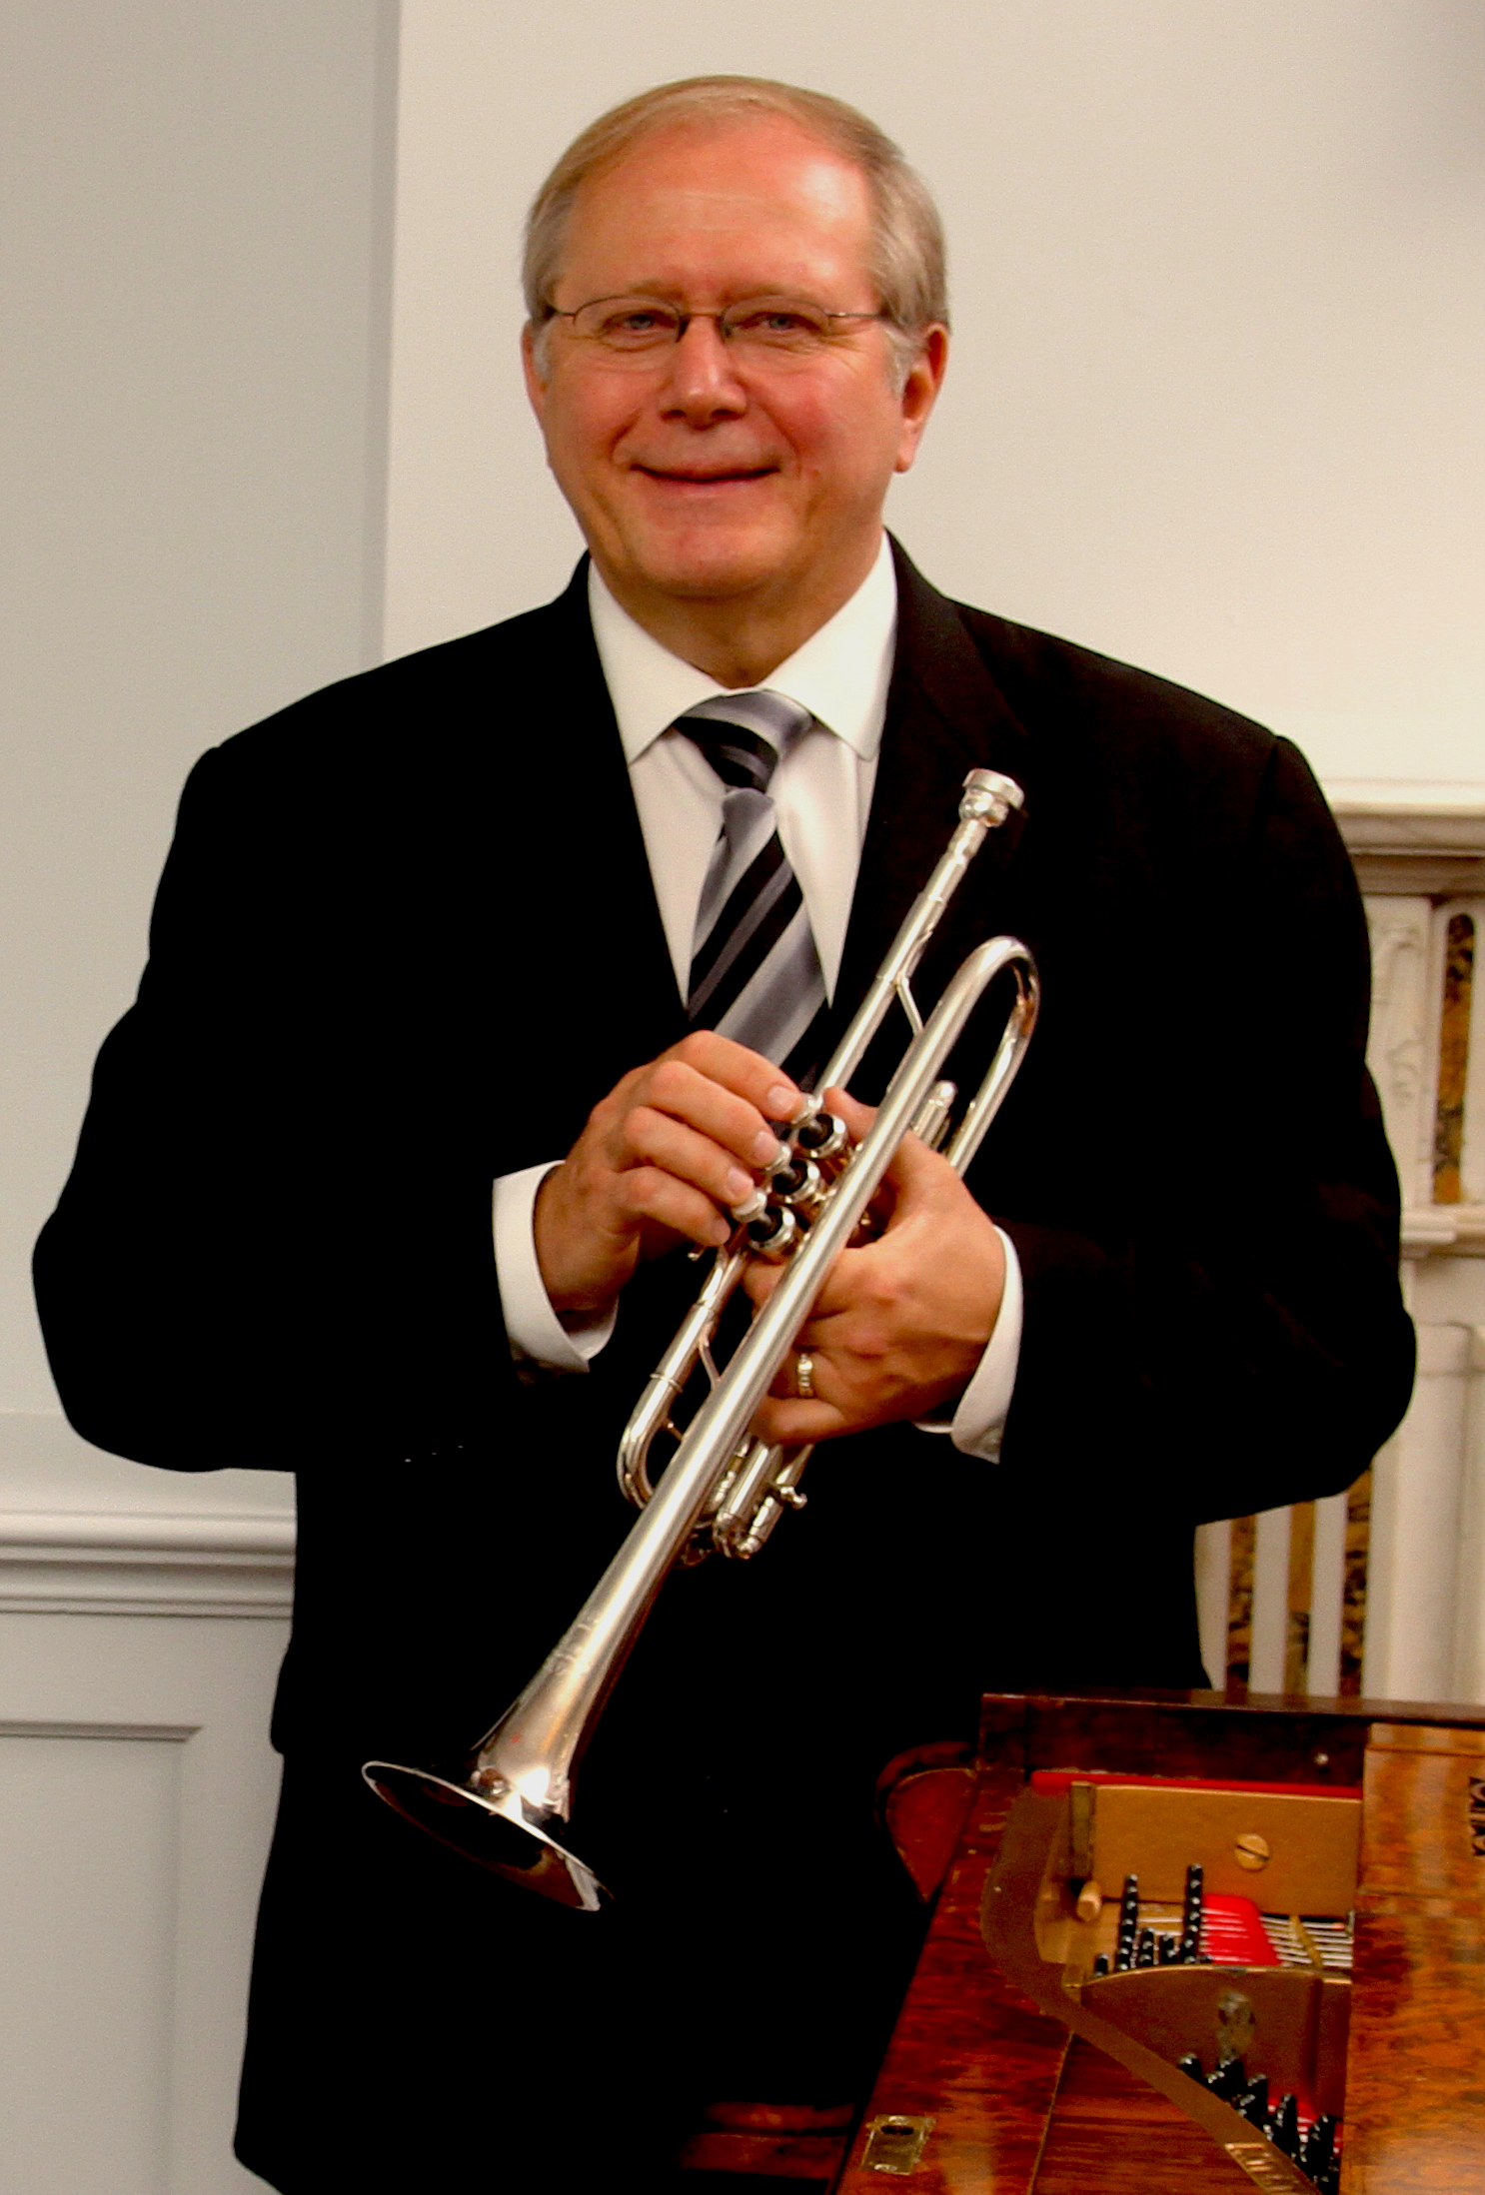
Trumpeter Chuck Seipp retired from The United States Army Band, “Pershing’s Own,” in 2012, culminating his 32-year career as Concert Band Group Leader. Sergeant Major Seipp performed at national, presidential and historical world events, at concerts and special events in Washington, D.C., and for funerals and wreath-laying ceremonies at the Tomb of The Unknown Soldier in Arlington National Cemetery. He performed with the Concert Band, Orchestra, Ceremonial Band, Herald Trumpets, Brass Quintet, and was a featured soloist. Chuck has toured and recorded solo trumpet and organ repertoire throughout Europe with world–renowned organist Diane Bish, appearing regularly on her “Joy of Music” television series. In addition, he has performed with The U.S. Army Brass Quintet. Through CJ Seipp Music Publications, he markets his own brass arrangements, many of which have been played and recorded by the Canadian Brass Quintet, The U.S. Army Brass Quintet and many groups around the world. Chuck’s recording project of The Wedding Book is a collection of his own arrangements and has proven to be a valuable resource for organists and trumpet players. As an active teacher, soloist, clinician and performer, he has performed locally with the National Symphony Orchestra, Washington Opera House Orchestra, Washington Ballet Orchestra, and Washington Bach Consort. He also leads and is active throughout the Mid-Atlantic Region with The Commonwealth Brass Quintet. Chuck enjoys his travels across the country with Arlington National Cemetery Ceremonial Organist, Dr. Randall Sheets, as the Seipp/Sheets Duo. He joined the faculty of Shenandoah Conservatory in Winchester, Virginia, in fall 2013 and previously served as visiting professor of trumpet at Texas Tech University in Lubbock, Texas, from August 2012 to May 2013. Chuck, Yamaha Performing Artist, holds an undergraduate music education degree from The University of Kansas and masters and doctoral degrees in trumpet performance from The Catholic University of America.

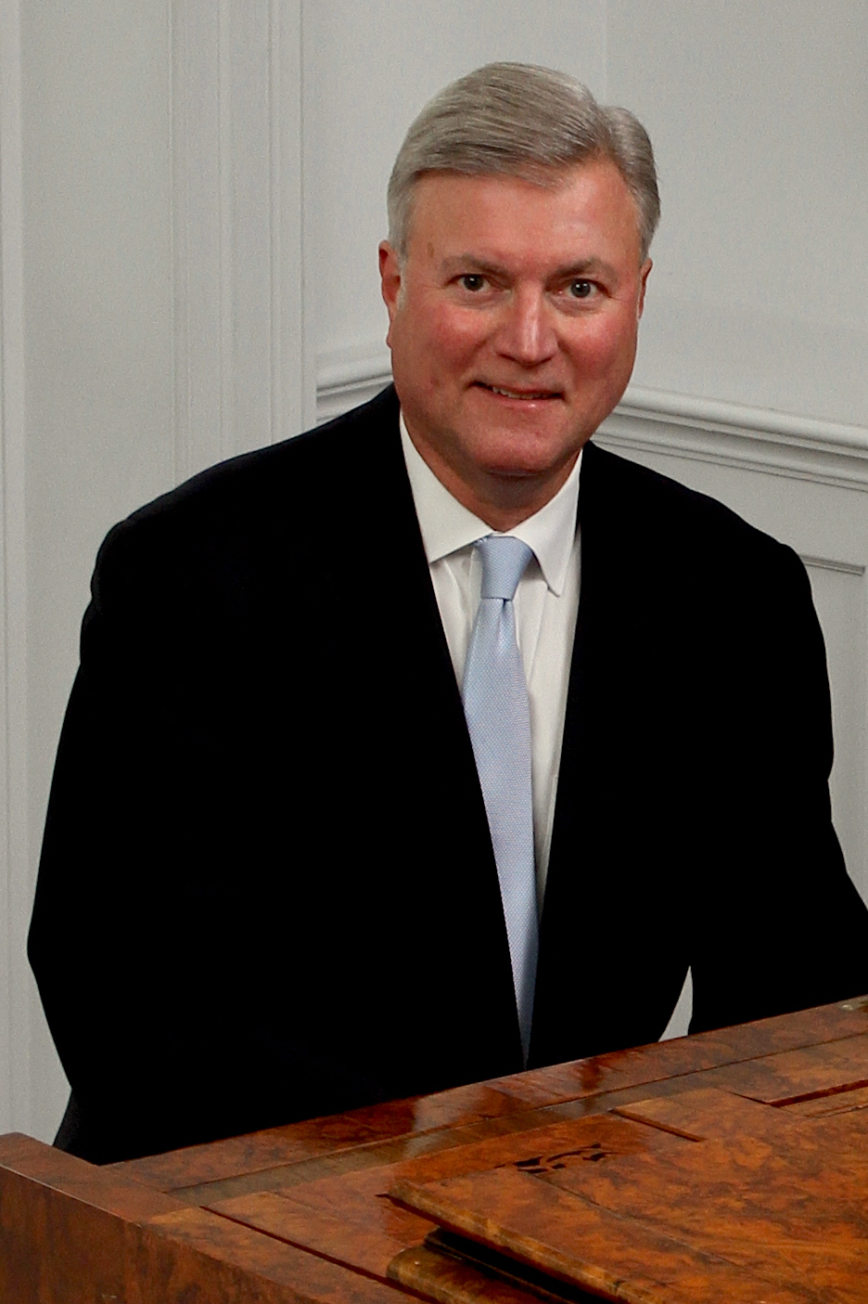
Randall Sheets began his musical studies in piano and organ while growing up in North Carolina. He holds degrees from Wittenberg University and Bowling Green State University, and received his doctorate from the University of Maryland. Throughout his graduate study Dr. Sheets taught at the University of Maryland and the Smithsonian Institution, and later taught at the Levine School of Music, the National Cathedral School, and the Landon School. His scholarly work includes several published articles and many lecture-recitals. In 1986, he was awarded the Liszt Commemorative Medal by the Hungarian Minister of Culture for his work as Festival Director of the Franz Liszt Centennial Celebration held in Washington, D.C. Dr. Sheets has been Ceremonial Organist for Arlington National Cemetery for over twenty years, where he performs over 1000 services a year in the historic Old Post Chapel and the Memorial Chapel.
He performs frequently with trumpeter Chuck Seipp in the Seipp/Sheets Trumpet and Organ Duo. In addition, he is the Organist/Music Director at Culpeper Baptist Church, and Organist for the First Church of Christ, Scientist, Mount Vernon. Concert appearances as an organist include programs at Washington National Cathedral, The Franciscan Monastery of the Holy Land, West Point Cadet Chapel, National City Christian Church, The Basilica of the Shrine of the Immaculate Conception, St. Luke’s Catholic Church, McLean, and historic Bruton Parish in Williamsburg, Virginia as well as churches in Illinois, Wisconsin, Minnesota, Iowa, South Dakota, Kansas, Missouri, North Carolina, South Carolina, Georgia and Florida.

