Seipp / Sheets Duo
Trumpet and Organ

Engaging ~ Innovative ~ Entertaining ~ Virtuosic ~ Diverse

A Unique Concert Blend Of Music And Video

When planning your concert season programs, consider inviting the Seipp / Sheets Trumpet & Organ Duo.

Trumpeter Chuck Seipp and organist Randall Sheets are two performers at the top of their craft. As the Seipp/Sheets Duo, their programs feature a diverse array of classical, virtuoso, lyrical, humorous and patriotic works. The duo’s performances also include audience participation and video presentations, ranging from interactive videos, to patriotic imagery, to silent film.

Both are high-profile musicians in their own right. Dr. Sheets is ceremonial organist for Arlington National Cemetery, and Dr. Seipp is a Shenandoah Conservatory professor and Sergeant Major (retired) from The United States Army Band, "Pershing's Own.”

Their reputation for excellence as a duo has grown during the past four seasons, as they have performed more than 50 concerts in 20 states (including Piccolo Spoletto L’Organo, Washington National Cathedral, The Franciscan Monastery of the Holy Land, and West Point Cadet Chapel) and produced three recordings. In addition to standard repertoire and arrangements of their own, the Seipp/Sheets Duo regularly commissions new arrangements and compositions.

Listen To A YouTube Play-list From Our Two Recent CDs https://www.youtube.com/playlist?list=PLhn36dMRc_jLxwsfW8R_poZumpDEk6KMl

Three CDs Available On Request

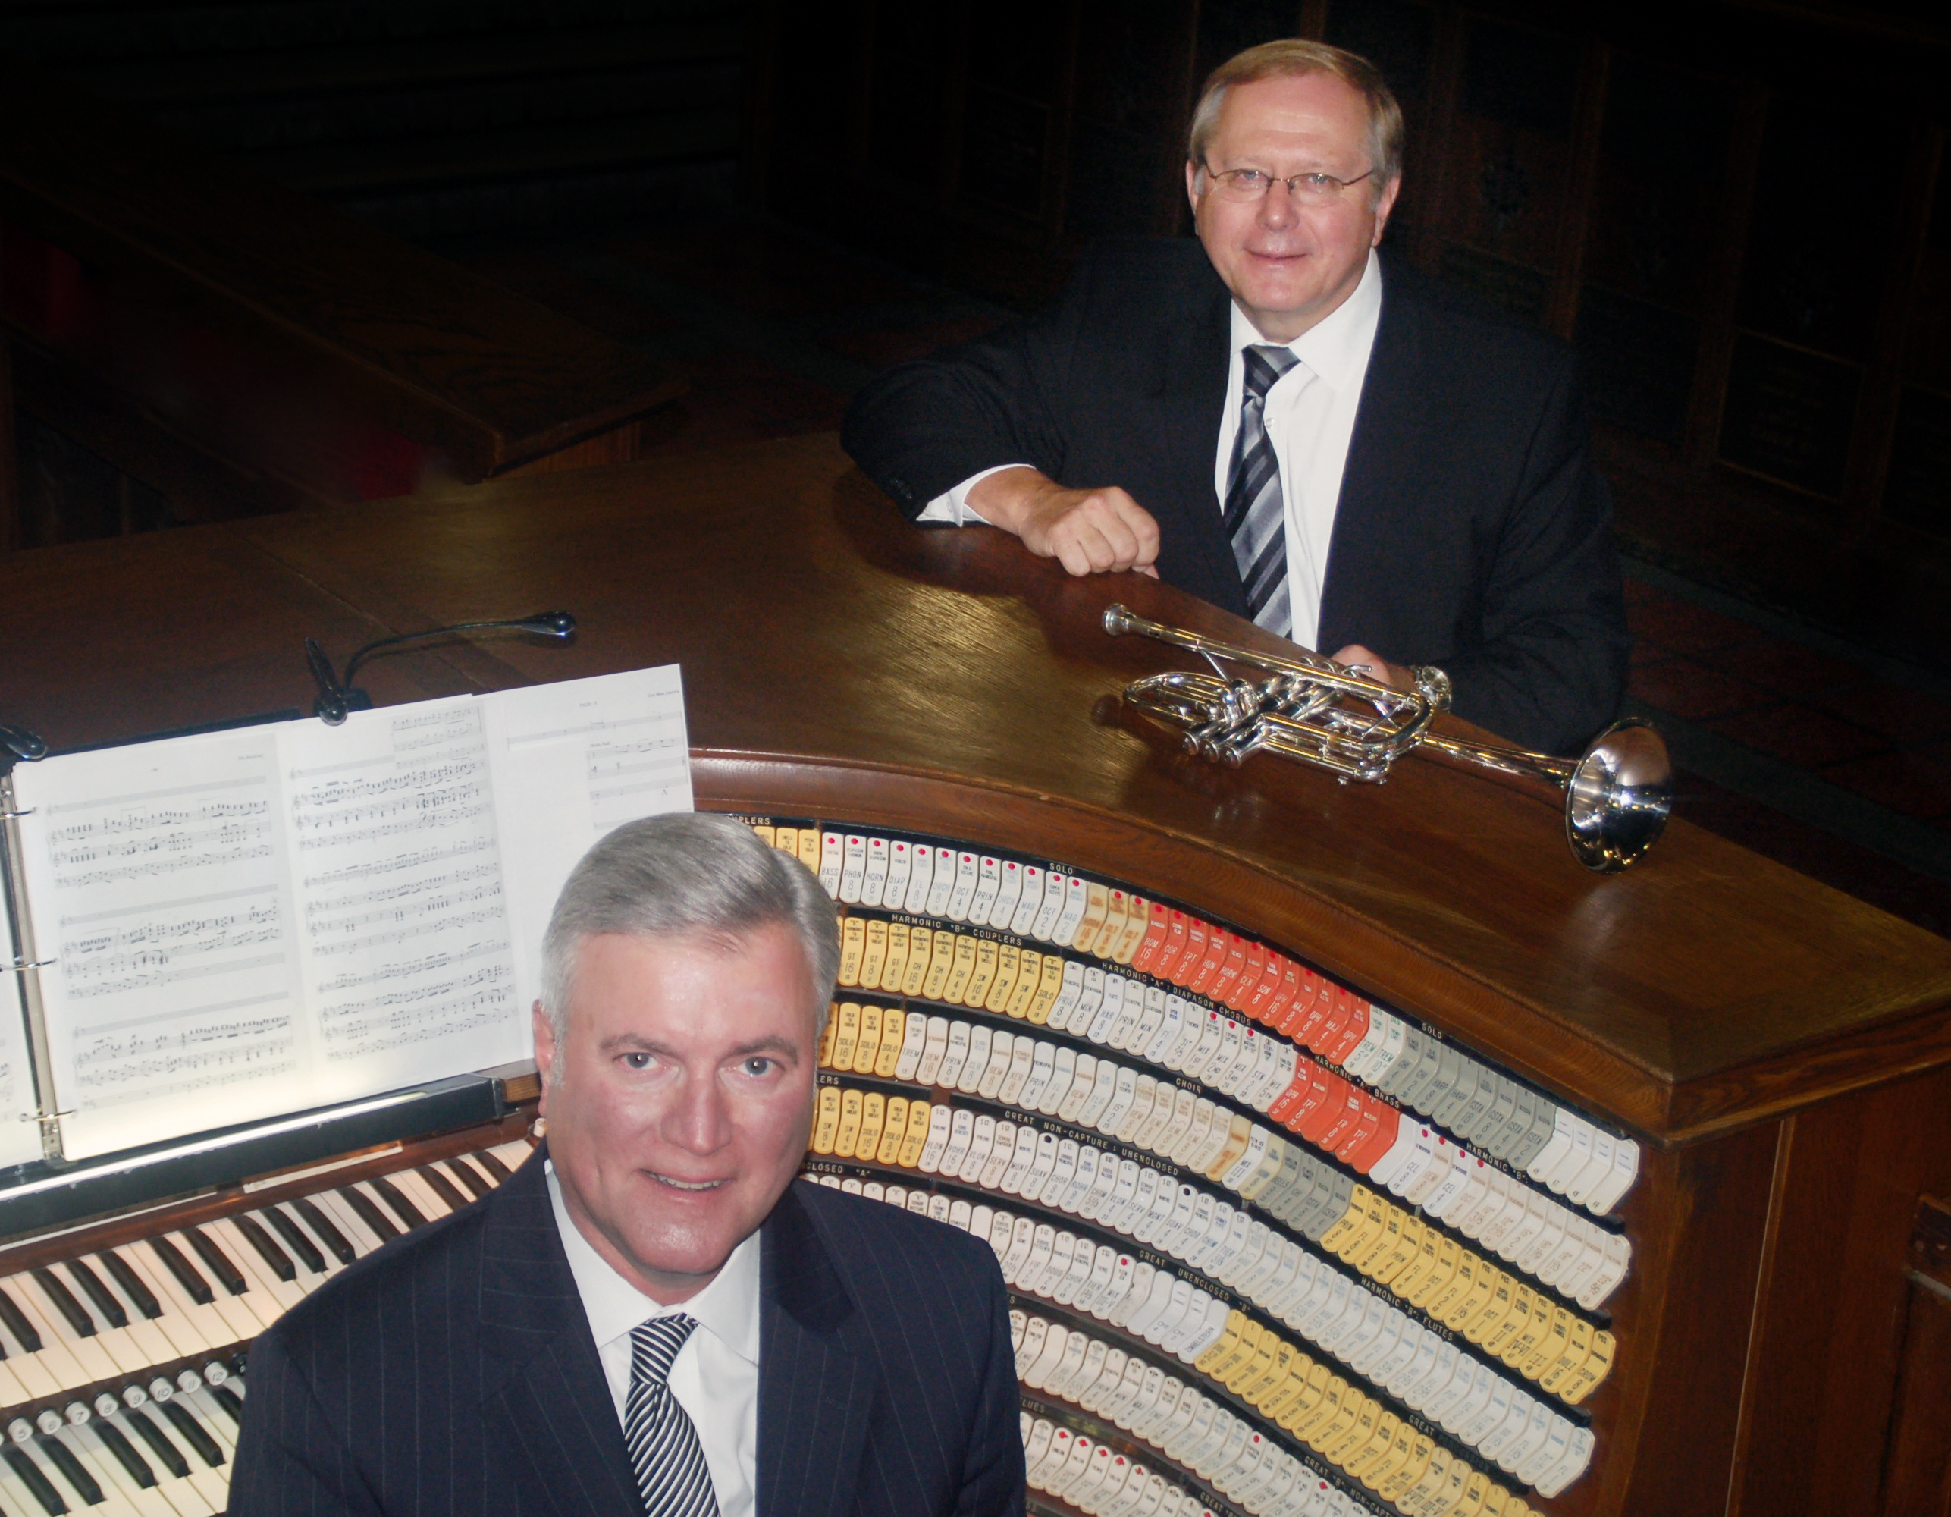

We would love to hear from you about a possible concert.
Thank you for your consideration and we look forward to hearing from you.

Chuck Seipp 703-517-0670 / chuckseipp@gmail.com Randall Sheets 540-842-4450 / randallksheets@gmail.com

Visit us on Facebook: Seipp/Sheets Trumpet and Organ Duo
For more information and recordings, visit our website at: seippsheetsduo.com

“What They Say”

"You thought you were coming today to hear a trumpeter. Wrong! You heard a superb musician whose instrument happens to be the trumpet. Six of them, as a matter of fact, were required for Dr. Chuck Seipp to achieve the various tone qualities that he was able to elicit from them. Couple this with an equally-gifted organist, Dr. Randall Sheets, and you have a program that elicited an instantaneous standing ovation from a very excited audience. All of this happened today at a L'Organo recital, part of the Piccolo Spoleto Festival in Charleston, SC."
Dr. Robert Gant / Chair, L'Organo 6/5/19

“The Seipp/Sheets Duo dazzled as they put on a beautifully crafted organ and trumpet recital that covered the entire gamut of repertoire from beloved favorites to even the serious music lovers' delights. Seipp utilized a forest of trumpets, showed off his virtuosity, impeccable articulation, tremendous phrasing and musicality, and even juggling skills while Sheets pulled out all the stops, displaying great soloistic and collaborative abilities on organ and piano. A truly great performance!”
Randy Lee, Professor of Trumpet, The University of Florida

“The audience loved the masterful artistry of this trumpet/organ duo. It was the highlight of our concert series.”
Gary Lamb, Commander (Retired), The United States Army Band, “Pershing’s Own”

“You are two of the finest performers anywhere. Fabulous recital from the first note to the last. You are such virtuoso yet incredibly
sensitive musicians and everything you play complements the other. What a treat for all of us to see and hear what really is possible
and talk about versatility! Your sound is so beautiful and flows so fluently. I have no words to adequately describe what I heard from your duo. Your dazzling technique doesn’t seem technical, just rich, glorious sound.”
Carter Eggers, Professor of Trumpet, Eastern Michigan University, Retired

“Fantastic musicianship, great programming,the audience was blown away!”
Jo Hodgin, Commissioner~Virginia Art Commission

"The Seipp/Sheets Duo played with sensitivity and brio, with comic glee and utter seriousness, with thoughtful attention to musical
tradition and an eye to contemporary composition and nuance. They left the audience wishing for more when the concert was over."
Mark Looker, Director, Kreft Arts Program, Concordia University, Ann Arbor, MI

“The abilities of this consummate musical duo to connect with the audience on both emotional and intellectual levels provided the
foundation for an inspiring performance epitomizing the very highest standards of programming, musicianship, and integrity.” Roger Stoner, Professor of Music (Trumpet), Retired, University of Kansas​

“The Seipp/Sheets Duo presented a splendid concert program, combining tremendous instrumental technique and artistry in all respects along with engaging programming. The balanced program delivered something to appeal to listeners of all types. Wonderful!
John Helgen, Director/Composer/Arranger, Roseville Lutheran Church, Roseville, MN

"Sunday's recital at Ft. Myer’s Old Post Chapel was absolutely stunning. Seipp met every musical challenge with a brilliant technique and gorgeous tone, switching among his array of trumpets with aplomb. Sheets proved to be not only a sympathetic partner at the organ and piano but also a virtuoso soloist.”
Roy Guenther, Professor Emeritus of Music Emeritus, GWU, DC

“The Seipp/Sheets Duo varied, exciting and virtuoso performance and ability to relate with their audience are only a few of the superlative attributes of this duo. Audiences have smiles on their faces knowing that they have heard music at the highest caliber.”
Steven Cooksey, Organ Professor Emeritus, Shenandoah Conservatory

“It was my pleasure to enjoy the Seipp/Sheets Trumpet and Organ Duo recently at First Presbyterian Church, Saginaw, MI. They are extremely sensitive to each other’s role in this collaborative effort, and there were times that I could not tell who was playing what.That speaks well to Randall Sheets’s use of the organ and to Chuck Seipp’s role as the solo instrumentalist. Their program featured music of many different styles and periods of music for trumpet and organ and was very well received by the audience. This is no ordinary collaboration of musicians: they are well worth hearing if they are performing in your area of the country.”
Steven Egler, Professor of Music Emeritus (Organ), Central Michigan University

“Your stunning arrangements and variety of repertoire made the wonderful evening memorable our community still talks about!” David Reynolds, Department Head, Trumpet Professor, South Dakota State University

“A musical compliment to each other combining a fantastic program.‘Elegy’ will be in my mind’s eye and ears for years to come” Jeffery Honoré, Director of Music, Holy Apostles Catholic Parish, New Berlin, WI

“Our audience loved your performance, our best concert ever! An amazing and wonderfully crafted program that ended
on such a high and emotional note with the salute to veterans”
Frank Zimmerman, Concert Series Chair, Bethany Lutheran Church, Crystal Lake, IL

“An amazing concert! Astonishing musicianship coupled with your humble hearts exceeded all expectations!”
Craig Williams, Organist/Choirmaster, United States Military Academy, West Point, NY

"The Seipp/Sheets Duo provided an afternoon of stellar music and convivial entertainment for our concert series in Saginaw. Chuck and Randy are consummate professionals who play with a superb degree of musicianship. Thank you for a memorable afternoon!"
Collin Whitfield, Director of Music Ministries, First Presbyterian Church, Saginaw, MI

“Thank you for the wonderful tour de force concert you presented in Brevard. Your terrific program was performed with such great skill, technique and musicality. The salute to the veterans was greatly appreciated by those attending. A superb performance!” Charlie Steele, Director/Organist, Brevard-Davidson River Presbyterian Church, Brevard, NC

“You guys were FANTASTIC! Every place I turn people are still RAVING about it. Your recital is being called a New York night!”
James Kriewald, Organist Christ Episcopal Church, Shenandoah University, Winchester, VA

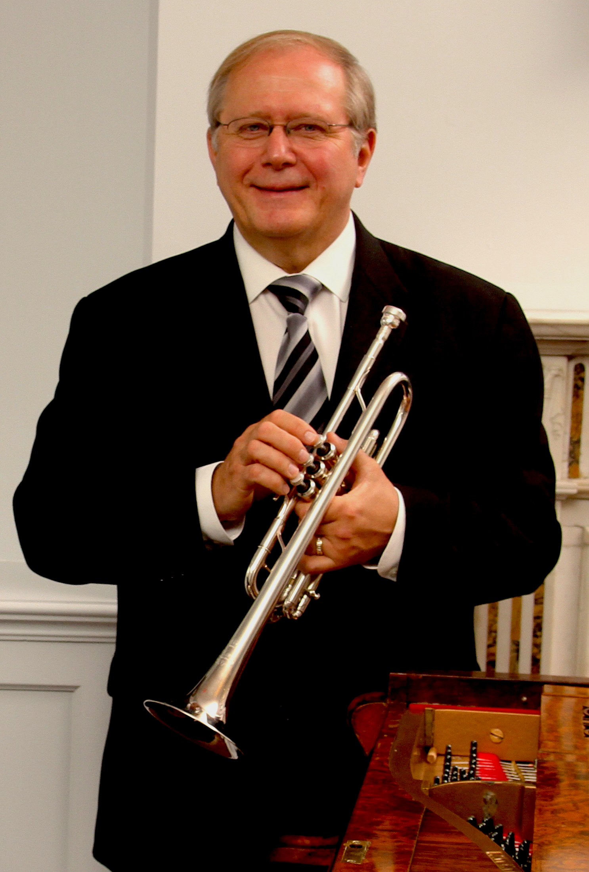
Trumpeter Chuck Seipp retired from The United States Army Band, “Pershing’s Own,” in 2012, culminating his 32-year career as Concert Band Group Leader. Sergeant Major Seipp performed at national, presidential and historical world events, at concerts and special events in Washington, D.C., and for funerals and wreath-laying ceremonies at the Tomb of The Unknown Soldier in Arlington National Cemetery. He performed with the Concert Band, Orchestra, Ceremonial Band, Herald Trumpets, Brass Quintet, and was a featured soloist. Chuck has toured and recorded solo trumpet and organ repertoire throughout Europe with world–renowned organist Diane Bish, appearing regularly on her “Joy of Music” television series. In addition, he has performed with The U.S. Army Brass Quintet. Through CJ Seipp Music Publications, he markets his own brass arrangements, many of which have been played and recorded by the Canadian Brass Quintet, The U.S. Army Brass Quintet and many groups around the world. Chuck’s recording project of The Wedding Book is a collection of his own arrangements and has proven to be a valuable resource for organists and trumpet players. As an active teacher, soloist, clinician and performer, he has performed locally with the National Symphony Orchestra, Washington Opera House Orchestra, Washington Ballet Orchestra, and Washington Bach Consort. He also leads and is active throughout the Mid-Atlantic Region with The Commonwealth Brass Quintet. Chuck enjoys his travels across the country with Arlington National Cemetery Ceremonial Organist, Dr. Randall Sheets, as the Seipp/Sheets Duo. He joined the faculty of Shenandoah Conservatory in Winchester, Virginia, in fall 2013 and previously served as visiting professor of trumpet at Texas Tech University in Lubbock, Texas, from August 2012 to May 2013. Chuck, Yamaha Performing Artist, holds an undergraduate music education degree from The University of Kansas and masters and doctoral degrees in trumpet performance from The Catholic University of America.

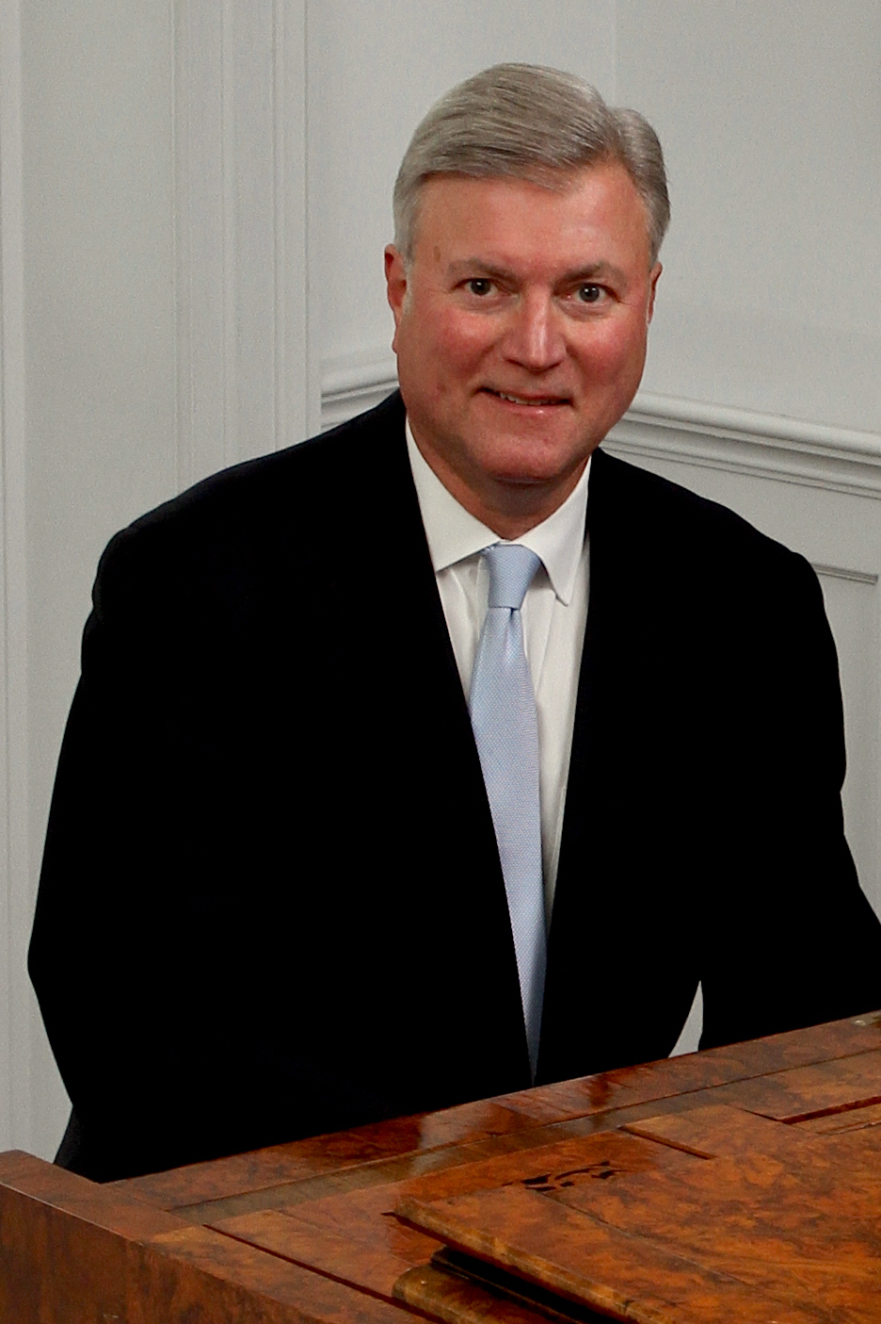
Randall Sheets began his musical studies in piano and organ while growing up in North Carolina. He holds degrees from Wittenberg University and Bowling Green State University, and received his doctorate from the University of Maryland. Throughout his graduate study Dr. Sheets taught at the University of Maryland and the Smithsonian Institution, and later taught at the Levine School of Music, the National Cathedral School, and the Landon School. His scholarly work includes several published articles and many lecture-recitals. In 1986, he was awarded the Liszt Commemorative Medal by the Hungarian Minister of Culture for his work as Festival Director of the Franz Liszt Centennial Celebration held in Washington, D.C. Dr. Sheets has been Ceremonial Organist for Arlington National Cemetery for the past twenty years, where he performs over 1000 services a year in the historic Old Post Chapel and the Memorial Chapel.
He performs frequently with trumpeter Chuck Seipp in the Seipp/Sheets Trumpet and Organ Duo.
In addition, he is the Organist/Music Director at Culpeper Baptist Church, and Organist for the First Church of Christ, Scientist, Mount Vernon. Concert appearances as an organist include programs at Washington National Cathedral, The Franciscan Monastery of the Holy Land, West Point Cadet Chapel, National City Christian Church, The Basilica of the Shrine of the Immaculate Conception, St. Luke’s Catholic Church, McLean, and historic Bruton Parish in Williamsburg, Virginia as well as churches in Illinois, Wisconsin, Minnesota, North Carolina, South Carolina, Iowa and South Dakota.

Seipp/Sheets Duo Performances
2019
Mar 8 Bald Head Island, NC 7:30PM The Village Chapel, Bald Head Island, NC
Mar 10 First Presbyterian Church 5PM, Savannah GA
Mar 13 University of Florida, 7:30PM University Auditorium, Gainesville
Mar 17 First Presbyterian Church 4PM, Jacksonville, FL
Apr 1 South Dakota State University, 7:30PM Brookings, SD
Apr 4 Performing Arts Center, 7:30PM Akron, IA
Apr 5 Dordt College Master Class Afternoon and Concert 7:30PM, Sioux Center IA
May 21 Country Club Christian Church 7:30PM, Kansas City
May 23 Trinity Lutheran Church, 7:30PM Topeka, Kansas
May 24 First Presbyterian Church 7:30PM, Warrensburg, Missouri
May 26 Kings Way United Methodist Church 3PM, Springfield Missouri
June 5 Piccolo Spoleto L’Organo Recital Series 10AM, First (Scots) Presbyterian, Charleston, SC
Sept 21 St. John's Lutheran Church 5PM, Franconia VA, Organ Dedication Concert
Oct 27 Culpeper Baptist Church 4PM, Culpeper, VA
Nov 3 Hood College Chapel, 4PM, Frederick, MD
Nov 8 Houston Baptist University, 1PM Houston, TX
Nov 10 St. John's Episcopal Church, 3PM, Dallas, TX
Nov 12 Texas Christian University, 7PM, Fort Worth, TX
Nov 24 First Presbyterian Church, 7PM, Annandale, VA, Organ Dedication Concert
2020
Feb 9 Franciscan Monastery Concert Series, Washington, DC 4PM Concert
Feb 16 Southwest New Jersey AGO Chapter, 4PM Concert
Mar 6 Cathedral Basilica of St. Augustine, Florida 7:30PM
Mar 8 Wesley United Methodist Church, 4PM Saint Simons Island, Georgia
Mar TBD Florida/Georgia
Nov 11 Concordia College, 7:30 Ann Arbor Michigan
Nov TBD Michigan and Ohio Concerts
2018
Mar 18 Franciscan Monastery 4PM, Washington, DC, Double Brass and Organ Concert
Apr 15 Culpeper Baptist Church 4PM, National Brass Quintet and Organ Concert
Apr 22 Cedar Lane Unitarian Church, Bethesda, MD, Brass and Organ Concert
May 22 St. Louis King of France 12:30PM, St. Paul, MN
May 24 First Presbyterian Church 7PM, Red Wing, MN
May 25 Roseville Lutheran Church 7PM, Roseville, MN
June 3 Washington National Cathedral 5:15PM, Washington, DC
Sept 9 St. Alban’s Episcopal Church Concert Series 4PM, Annandale, VA
Oct 8 The Village at Orchard Ridge AGO Trumpet/Organ Recital 7PM Winchester, VA
Oct 28 Culpeper Baptist Church 4PM, Culpeper, VA
Nov 6 Master Class Michigan State University
Nov 7 Peoples Church 7:30PM, East Lansing MI
Nov 9 Cherry Hill Presbyterian Church, 7:30PM, Dearborn, MI
Nov 10 First Presbyterian Church, 4PM, Saginaw, MI
Nov 11 Concordia University 7:30PM, Ann Arbor, MI
2017
Nov 11 Bryson City United Methodist Church, Bryson City NC
Nov 10 The Village Chapel, Bald Head Island, NC
Nov 5 First Presbyterian, Greenville, SC
Nov 3 Brevard-Davidson Presbyterian Church, Brevard, NC
Oct 29 Culpeper Baptist Church, Culpeper, VA
Sept 30 Shenandoah Conservatory Goodson Recital Hall, Winchester, VA
Sept 11 Village at Orchard Ridge AGO Event, Winchester, VA
Mar 26 Franciscan Monastery Concert Series, Washington, DC
2016
Nov 11 First Congregational Church, Sioux Falls, SD
Nov 10 First United Methodist Church, Brookings, SD
Nov 8 Birdie and Carol Harris School of Performing Arts, Akron, IA
Nov 6 St. John’s United Methodist Church, Aiken, SC
Oct 20 Randolph-Macon Military Academy, Front Royal, VA
Aug 28 Christ Episcopal Church, Winchester, VA
June 16 Museum of the Shenandoah Valley, Winchester, VA
Nov 15 Bethany Lutheran Church, Chicago, IL
Nov 14 Holy Apostles Catholic Church, New Berlin, WI
Nov 8 West Point Military Academy Cadet Chapel, West Point

