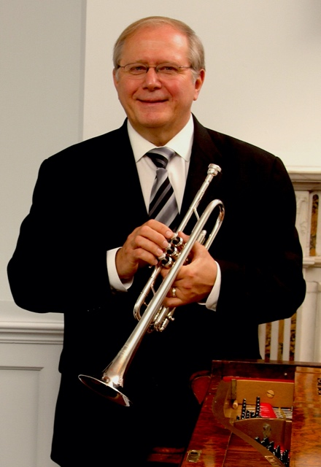
Trumpeter Chuck Seipp retired from The United States Army Band, “Pershing’s Own,” in 2012, culminating his 32-year career as Concert Band Group Leader. Sergeant Major Seipp performed at national, presidential and historical world events, at concerts and special events in Washington, D.C., and for funerals and wreath-laying ceremonies at the Tomb of The Unknown Soldier in Arlington National Cemetery. He performed with the Concert Band, Orchestra, Ceremonial Band, Herald Trumpets, Brass Quintet, and was a featured soloist.

Chuck has toured and recorded solo trumpet and organ repertoire throughout Europe with world–renowned organist Diane Bish, appearing regularly on her “Joy of Music” television series. In addition, he has performed with The U.S. Army Brass Quintet. As an active teacher, soloist, clinician and performer, he has performed locally with the National Symphony Orchestra, Washington Opera House Orchestra, Washington Ballet Orchestra, and Washington Bach Consort. He also leads and is active throughout the Mid-Atlantic Region with The Commonwealth Brass Quintet. Chuck enjoys his travels across the country with Arlington National Cemetery Ceremonial Organist, Dr. Randall Sheets, as the Seipp/Sheets Duo.

Through CJ Seipp Music Publications, he markets his own brass arrangements, many of which have been played and recorded by the Canadian Brass Quintet, The U.S. Army Brass Quintet and many groups around the world. Chuck’s recording project of The Wedding Book is a collection of his own arrangements and has proven to be a valuable resource for organists and trumpet players.

He served on faculty as adjunct professor of trumpet at Shenandoah University in Winchester, Virginia, from August 2013 to May 2019 and previously served as visiting professor of trumpet at Texas Tech University in Lubbock, Texas, from August 2012 to May 2013.

Chuck, Yamaha Performing Artist, holds an undergraduate music education degree from The University of Kansas and masters and doctoral degrees in trumpet performance from The Catholic University of America.

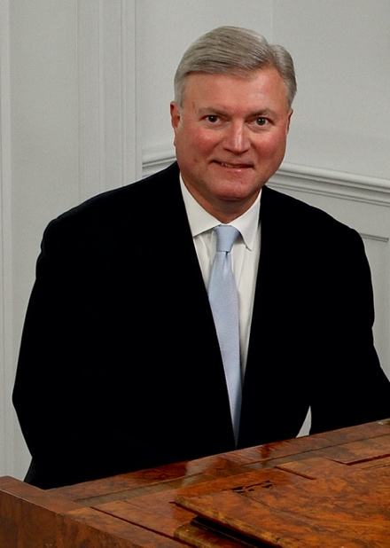
Randall Sheets is the Ceremonial Organist for Arlington National Cemetery, where for the past twenty-one years he has honored our fallen veterans while performing over 1000 services per year in the historic Old Post Chapel and the Memorial Chapel. He serves as a resource for military chaplains and families in planning services, and has performed services for dignitaries and government officials at the highest levels including senators, Supreme Court justices, secretaries of state and congressmen.

A graduate of Wittenberg University, he studied with William Walters (piano) Trudy Faber (harpsichord) and Cheryl Colantonio (organ), then received a MM from Bowling Green State University under Jerome Rose (piano) and Vernon Wolcott (organ) and a DMA under Thomas Schumacher (piano) at the University of Maryland. Throughout his graduate study Dr. Sheets taught at the University of Maryland and the Smithsonian Institution, and later taught at the Levine School of Music, the National Cathedral School, and the Landon School. His scholarly work includes several published articles and many lecture-recitals. He was awarded the Liszt Commemorative Medal by the Hungarian Minister of Culture in 1986 for his work as Festival Director of the Franz Liszt Centennial Celebration held in Washington, D.C.

Dr. Sheets tours frequently with trumpeter Chuck Seipp in the Seipp/Sheets Duo. They have performed over 60 concerts during the last five seasons in twenty-one states at universities, churches and festivals. Their concerts are an innovative blend of standard repertoire, patriotic programs, and contemporary arrangements with video. They continue to commission many new arrangements and compositions, and also compose their own arrangements.

As a church musician, Dr. Sheets has extensive experience as a choral conductor, handbell director, and producing and managing concert series. He is the Organist/Choir Director at Culpeper Baptist Church, and serves as the Artistic Director of the Culpeper Concert Series. He is also Organist for the First Church of Christ, Scientist, Mount Vernon. Concert appearances as an organist include programs at Washington National Cathedral, The Franciscan Monastery of the Holy Land, West Point Cadet Chapel, National City Christian Church, The Basilica of the Shrine of the Immaculate Conception, St. Luke’s Catholic Church, McLean, historic Bruton Parish in Williamsburg, Virginia, and Piccolo Spoleto Festival in Charleston, South Carolina.

