Seipp / Sheets Duo
Trumpet and Organ

Engaging ~ Innovative ~ Entertaining ~ Virtuosic ~ Diverse

A Unique Concert Blend Of Music And Video
The Seipp/Sheets Trumpet & Organ Duo is unlike any ensemble performing today. Custom musical arrangements of virtuoso, beautiful, entertaining, humorous and patriotic selections enhance the exquisite blend of their instruments. Coupled visually with specialized videos, Seipp and Sheets craft a unique and engaging concert experience for all ages, creating extraordinary connection with their audiences. The duo’s thoughtful programming, artistic arrangements and powerful, innovative and interactive video presentations make the Seipp/Sheets Duo today’s musicians to watch.

Trumpeter Chuck Seipp and organist Randall Sheets are two performers at the top of their craft. Both are high-profile musicians in their own right. Dr. Sheets is Ceremonial Organist for Arlington National Cemetery, and Dr. Seipp is Sergeant Major (retired) from The United States Army Band, "Pershing's Own” in Washington, DC. For the past several seasons, the Seipp/Sheets Duo has performed as many as 25 programs yearly to enthusiastic audiences across America for church concert series, universities, organ guild chapters and were featured at the prestigious Piccolo Spoleto Organ Festival. In addition to the music they produce, Chuck and Randall regularly commission new arrangements, compositions and videos.

Enclosed is a listing of YouTube recordings, reviews, bios and performance history and for more information visit: www.seippsheetsduo.com / Seipp Sheets Trumpet & Organ Duo ~ FaceBook

We hope you consider hosting The Seipp/Sheets Duo for a future program and we look forward
to speaking with you about the possibility of joining your community for a concert.

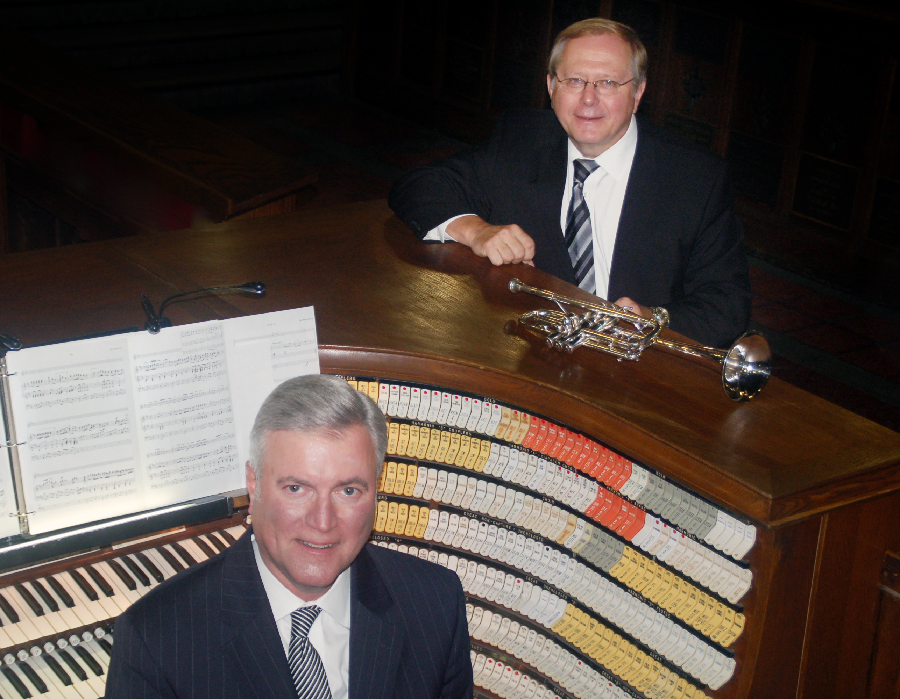
Chuck Seipp 703-517-0670 / chuckseipp@gmail.com
Randall Sheets 540-842-4450 / randallksheets@gmail.com

LISTEN TO A YOUTUBE PLAYLIST FROM OUR RECENT CD’s

https://www.youtube.com/playlist?list=PLhn36dMRc_jLU1_KVUAwkTzJD7Mqc-nL7

FOUR CDs AVAILABLE ON REQUEST

“What They Say”

"You thought you were coming today to hear a trumpeter. Wrong! You heard a superb musician whose instrument happens to be the trumpet.
Six of them, as a matter of fact, were required for Dr. Chuck Seipp to achieve the various tone qualities that he was able to elicit from them.
Couple this with an equally gifted organist, Dr. Randall Sheets, and you have a program that elicited an instantaneous standing ovation from
a very excited audience. All of this happened today at a L'Organo recital, part of the Piccolo Spoleto Festival in Charleston, SC."
Dr. Robert Gant / Chair, L'Organo 6/5/19

“The Seipp/Sheets Duo dazzled as they put on a beautifully crafted organ and trumpet recital that covered repertoire from beloved favorites to
serious music lovers' delights. Seipp showed off his virtuosity, impeccable articulation, tremendous phrasing and musicality, and even juggling
skills while Sheets pulled out all the stops, displaying great soloistic and collaborative abilities on organ and piano. A terrific performance!”
Randy Lee, Professor of Trumpet, The University of Florida

“The audience loved the masterful artistry of this trumpet/organ duo. It was the highlight of our concert series.”
Gary Lamb, Commander (Retired), The United States Army Band, “Pershing’s Own”

“Two of the finest performers anywhere. Fabulous recital from first note to last. Virtuoso yet incredibly sensitive musicians who complemented
each other. What a treat for all of us to see and hear what really is possible. Talk about versatility and sound so beautiful that flows so fluently.
I have no words to adequately describe what I heard. Your dazzling technique doesn’t seem technical, just rich, glorious sound.”
Carter Eggers, Professor of Trumpet, Eastern Michigan University, Retired

“Fantastic musicianship, great programming, the audience was blown away!”
Jo Hodgin, Commissioner~Virginia Arts Commission

“I can't thank you enough for providing such an outstanding event for our AGO chapter and the Moorestown community. Your program was challenging and interesting, but what came across throughout was the joy of sharing music with the audience. It was an inspiring concert!”
Vernon Williams, Dean, Southwest Jersey Chapter of the American Guild of Organists

"The Seipp/Sheets Duo played with sensitivity and brio, with comic glee and utter seriousness, with thoughtful attention to musical
tradition and an eye to contemporary composition and nuance. They left the audience wishing for more when the concert was over."
Mark Looker, Director, Kreft Arts Program, Concordia University, Ann Arbor, MI

“The abilities of this consummate musical duo to connect with the audience on both emotional and intellectual levels provided the
foundation for an inspiring performance epitomizing the very highest standards of programming, musicianship, and integrity.”
Roger Stoner, Professor of Music (Trumpet), Retired, University of Kansas​

“The Seipp/Sheets Duo presented a splendid concert program, combining tremendous instrumental technique and artistry in all respects along
with engaging programming. The balanced program delivered something to appeal to listeners of all types. Wonderful!
John Helgen, Director/Composer/Arranger, Roseville Lutheran Church, Roseville, MN

"Sunday's recital at Ft. Myer’s Old Post Chapel was stunning. Seipp met every musical challenge with a brilliant technique and gorgeous tone, switching among his array of trumpets. Sheets proved to be not only a sympathetic partner at the organ and piano but also a virtuoso soloist.”
Roy Guenther, Professor Emeritus of Music Emeritus, GWU, DC

“The Seipp/Sheets Trumpet and Organ Duo are returning for a third season and are the most entertaining duo to ever grace the Chapel.”
Friends of Music Concert Series, The Village Chapel, Bald Head Island, NC

“The Seipp/Sheets Duo exciting and virtuoso performance with ability to relate to their audience are only a few superlatives of this duo!”
Steven Cooksey, Organ Professor Emeritus, Shenandoah Conservatory

“What a pleasure to enjoy the Seipp/Sheets Trumpet and Organ Duo at First Presbyterian, Saginaw. They are extremely sensitive to each
other’s role and times I could not tell who was playing what which speaks well to Randall’s use of the organ and Chuck’s role as soloist.
Steven Egler, Professor of Music Emeritus (Organ), Central Michigan University

“Your stunning arrangements and variety of repertoire made the wonderful evening memorable our community still talks about!”
David Reynolds, Department Head, Trumpet Professor, South Dakota State University

"The Seipp Sheets Duo gave an amazing performance! Not only were we impressed with Chuck and Randy's level of artistry but we were
also very much entertained. Everyone I spoke with after the concert was dazzled by what they heard and saw."
Vicki Nichols, Sub-Dean, Southwest Jersey Chapter of the American Guild of Organists

“A musical compliment to each other combining a fantastic program. ‘Elegy’ will be in my mind’s eye and ears for years to come” Jeffery Honoré, Director of Music, Holy Apostles Catholic Parish, New Berlin, WI

“Our audience loved your performance, our best concert ever! An amazing and wonderfully crafted program that ended
on such a high and emotional note with the salute to veterans. This is no ordinary collaboration.”
Frank Zimmerman, Concert Series Chair, Bethany Lutheran Church, Crystal Lake, IL

“An amazing concert! Astonishing musicianship coupled with your humble hearts exceeded all expectations!”
Craig Williams, Organist/Choirmaster, United States Military Academy, West Point, NY

"The Seipp/Sheets Duo provided an afternoon of stellar music and convivial entertainment for our concert series in Saginaw. Chuck and
Randy are consummate professionals who play with a superb degree of musicianship. Thank you for a memorable afternoon!"
Collin Whitfield, Director of Music Ministries, First Presbyterian Church, Saginaw, MI

“Thank you for the wonderful tour de force concert you presented in Brevard. Your terrific program was performed with such great skill,
technique and musicality. The salute to the veterans was greatly appreciated by those attending. A superb performance!”
Charlie Steele, Director/Organist, Brevard-Davidson River Presbyterian Church, Brevard, NC

“You guys were FANTASTIC! Every place I turn people are still RAVING about it. Your recital is being called a New York night!”
James Kriewald, Organist Christ Episcopal Church, Shenandoah University, Winchester, VA

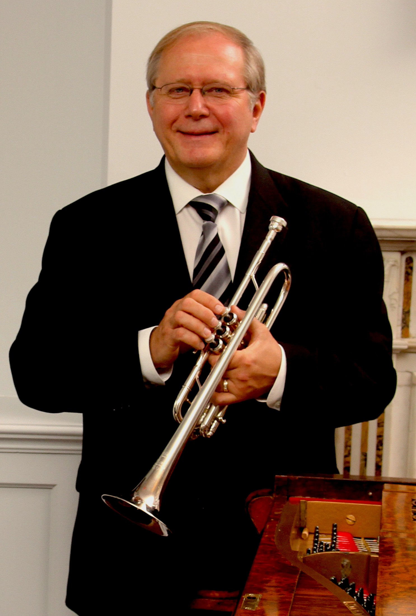
Trumpeter Chuck Seipp retired from The United States Army Band, “Pershing’s Own,” in 2012, culminating his 32-year career as Concert Band Group Leader. Sergeant Major Seipp performed at national, presidential and historical world events, at concerts and special events in Washington, D.C., and for funerals and wreath-laying ceremonies at the Tomb of The Unknown Soldier in Arlington National Cemetery. He performed with the Concert Band, Orchestra, Ceremonial Band, Herald Trumpets, Brass Quintet, and was a featured soloist.

Chuck has toured and recorded solo trumpet and organ repertoire throughout Europe with world–renowned organist Diane Bish, appearing regularly on her “Joy of Music” television series. In addition, he has performed with The U.S. Army Brass Quintet. As an active teacher, soloist, clinician and performer, he has performed locally with the National Symphony Orchestra, Washington Opera House Orchestra, Washington Ballet Orchestra, and Washington Bach Consort. He also leads and is active throughout the Mid-Atlantic Region with The Commonwealth Brass Quintet. Chuck enjoys his travels across the country with Arlington National Cemetery Ceremonial Organist, Dr. Randall Sheets, as the Seipp/Sheets Duo.

Through CJ Seipp Music Publications, he markets his own brass arrangements, many of which have been played and recorded by the Canadian Brass Quintet, The U.S. Army Brass Quintet and many groups around the world. Chuck’s recording project of The Wedding Book is a collection of his own arrangements and has proven to be a valuable resource for organists and trumpet players.

He served on faculty as adjunct professor of trumpet at Shenandoah University in Winchester, Virginia, from August 2013 to May 2019 and previously served as visiting professor of trumpet at Texas Tech University in Lubbock, Texas, from August 2012 to May 2013.

Chuck, Yamaha Performing Artist, holds an undergraduate music education degree from The University of Kansas and masters and doctoral degrees in trumpet performance from The Catholic University of America.

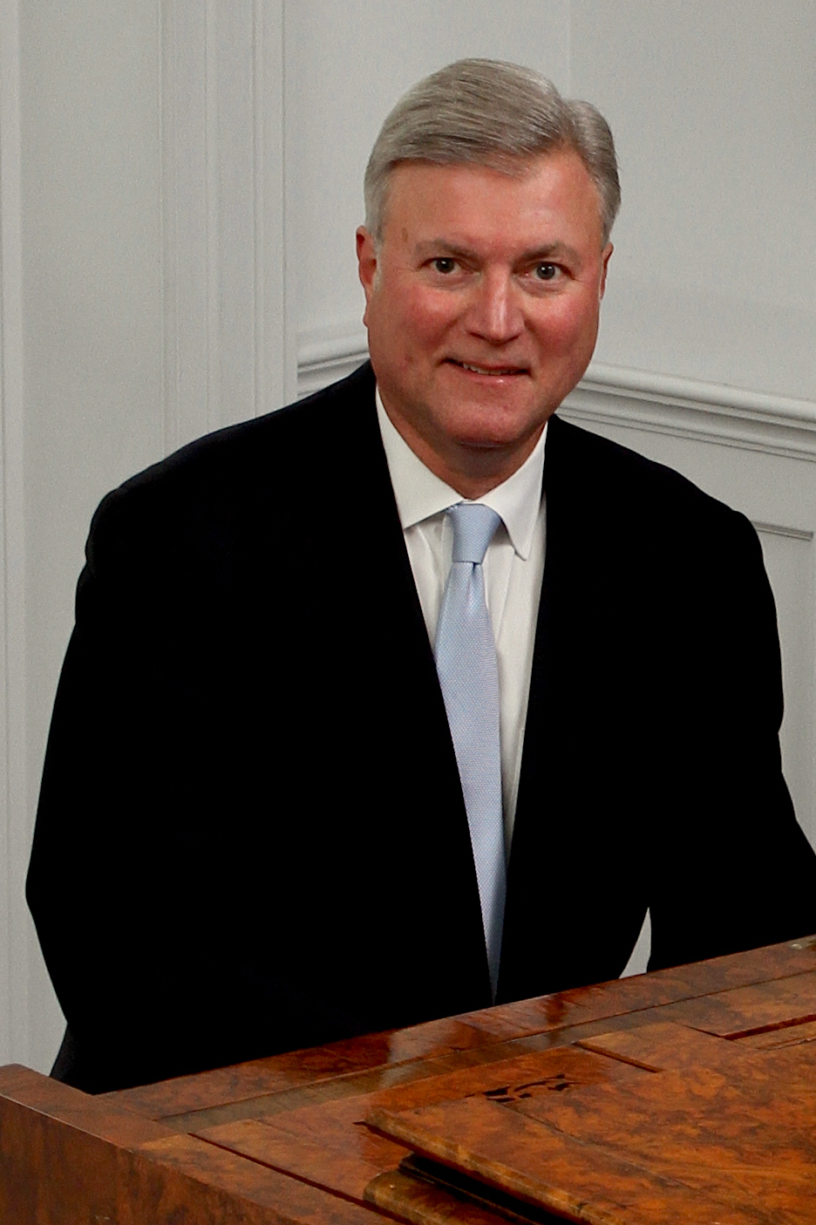
Randall Sheets is the Ceremonial Organist for Arlington National Cemetery, where for the past twenty-one years he has honored our fallen veterans while performing over 1000 services per year in the historic Old Post Chapel and the Memorial Chapel. He serves as a resource for military chaplains and families in planning services, and has performed services for dignitaries and government officials at the highest levels including senators, Supreme Court justices, secretaries of state and congressmen.

A graduate of Wittenberg University, he studied with William Walters (piano) Trudy Faber (harpsichord) and Cheryl Colantonio (organ), then received a MM from Bowling Green State University under Jerome Rose (piano) and Vernon Wolcott (organ) and a DMA under Thomas Schumacher (piano) at the University of Maryland. Throughout his graduate study Dr. Sheets taught at the University of Maryland and the Smithsonian Institution, and later taught at the Levine School of Music, the National Cathedral School, and the Landon School. His scholarly work includes several published articles and many lecture-recitals. He was awarded the Liszt Commemorative Medal by the Hungarian Minister of Culture in 1986 for his work as Festival Director of the Franz Liszt Centennial Celebration held in Washington, D.C.

Dr. Sheets tours frequently with trumpeter Chuck Seipp in the Seipp/Sheets Duo. They have performed over 60 concerts during the last five seasons in twenty-one states at universities, churches and festivals. Their concerts are an innovative blend of standard repertoire, patriotic programs, and contemporary arrangements with video. They continue to commission many new arrangements and compositions, and also compose their own arrangements.

As a church musician, Dr. Sheets has extensive experience as a choral conductor, handbell director, and producing and managing concert series. He is the Organist/Choir Director at Culpeper Baptist Church, and serves as the Artistic Director of the Culpeper Concert Series. He is also Organist for the First Church of Christ, Scientist, Mount Vernon. Concert appearances as an organist include programs at Washington National Cathedral, The Franciscan Monastery of the Holy Land, West Point Cadet Chapel, National City Christian Church, The Basilica of the Shrine of the Immaculate Conception, St. Luke’s Catholic Church, McLean, historic Bruton Parish in Williamsburg, Virginia, and Piccolo Spoleto Festival in Charleston, South Carolina.

Seipp/Sheets Duo Performances
2020
Feb 9 Franciscan Monastery Concert Series, Washington, D.C. 4PM Concert
Feb 16 Southwest New Jersey AGO Chapter, 4PM Concert, Moorestown UMC, NJ
Mar 6 Cathedral Basilica of St. Augustine, FL 7:30PM
Mar 27 The Village Chapel, 7:30PM, Bald Head Island, NC POSTPONED TBD
Apr 19 Wesley United Methodist Church, 3PM, Saint Simons Island, GA POSTPONED TBD
May 3 St. John’s Episcopal Church, 4PM Olney, MD POSTPONED TBD
May 8 Saint Mary’s Catholic Church, 8PM Concert, Fredericksburg, VA POSTPONED TBD
July 4 Culpeper Baptist Church, Patriotic Program, 4PM, Culpeper, VA LIVE STREAMED
Sept 20 Trinity Evangelical Lutheran Church, 5PM, Hagerstown, MD POSTPONED TBD
Oct 9 Pine Street Presbyterian Church, 7PM, Harrisburg PA POSTPONED TBD
Oct 25 Culpeper Baptist Church, 4PM, Culpeper, VA POSTPONED TBD
Nov 8 Our Lady, Queen of the Most Holy Rosary Cathedral, 3PM Toledo, OH POSTPONED NOV 2021
Nov 9 Grace Episcopal Church, 7:30PM Sandusky, OH POSTPONED NOV 2021
Nov 11 Concordia University, 7PM Ann Arbor, MI POSTPONED NOV 2021
Nov 13 Cherry Hill Presbyterian Church, 7:30PM, Dearborn, MI POSTPONED NOV 2021
Nov 11 Ft. Myer Old Post Chapel, Veterans Day Tribute Live Stream ~ 11AM Seipp/Sheets Trumpet & Organ Duo FaceBook Page
Dec 10 Ft. Myer Old Post Chapel, Christmas Live Stream, Ft. Myer, VA
Dec 13 Culpeper Baptist Church Christmas Live Stream, 4PM Culpeper, VA
RESCHEDULE OF (12) 2020 CONCERTS TO 2021 DUE TO COVID-19 ~ TBD
2021
Feb 28 Home Moravian Church, 3PM, Winston-Salem, NC
May 2 Christian Community Presbyterian Church, 4PM, Bowie, MD POSTPONED TBD
May 31 Clay Center Kansas Performing Arts Center, Noon Concert
May Kansas, Missouri Tour
Nov Michigan Tour
2019
Mar 8 Bald Head Island, NC 7:30PM The Village Chapel, Bald Head Island, NC
Mar 10 First Presbyterian Church 5PM, Savannah GA
Mar 13 University of Florida, 7:30PM University Auditorium, Gainesville
Mar 17 First Presbyterian Church 4PM, Jacksonville, FL
Apr 1 South Dakota State University, 7:30PM Brookings, SD
Apr 4 Performing Arts Center, 7:30PM Akron, IA
Apr 5 Dordt College Master Class Afternoon and Concert 7:30PM, Sioux Center IA
May 21 Country Club Christian Church 7:30PM, Kansas City, MO
May 23 Trinity Lutheran Church, 7:30PM Topeka, KS
May 24 First Presbyterian Church 7:30PM, Warrensburg, MO
May 26 Kings Way United Methodist Church 3PM, Springfield MO
June 5 Piccolo Spoleto L’Organo Recital Series 10AM, First (Scots) Presbyterian, Charleston, SC
Sept 21 St. John's Lutheran Church 5PM, Alexandria, VA, Organ Dedication Concert
Oct 27 Culpeper Baptist Church 4PM, Culpeper, VA
Nov 3 Hood College Chapel, 4PM, Frederick, MD
Nov 8 Houston Baptist University, 1PM Houston, TX
Nov 10 St. John's Episcopal Church, 3PM, Dallas, TX
Nov 12 Texas Christian University, 7PM, Fort Worth, TX
Nov 24 First Presbyterian Church, 7PM, Annandale, VA, Organ Dedication Concert
Dec 8 Washington Street UMC, 4:30, Old Town Alexandria, VA
2018
Mar 18 Franciscan Monastery 4PM, Washington, DC, Double Brass and Organ Concert
Apr 15 Culpeper Baptist Church 4PM, National Brass Quintet and Organ Concert
Apr 22 Cedar Lane Unitarian Church, Bethesda, MD, Brass and Organ Concert
May 22 St. Louis King of France 12:30PM, St. Paul, MN
May 24 First Presbyterian Church 7PM, Red Wing, MN
May 25 Roseville Lutheran Church 7PM, Roseville, MN
June 3 Washington National Cathedral 5:15PM, Washington, DC
Sept 9 St. Alban’s Episcopal Church Concert Series 4PM, Annandale, VA
Oct 8 The Village at Orchard Ridge AGO Trumpet/Organ Recital 7PM Winchester, VA
Oct 28 Culpeper Baptist Church 4PM, Culpeper, VA
Nov 6 Master Class Michigan State University
Nov 7 Peoples Church 7:30PM, East Lansing MI
Nov 9 Cherry Hill Presbyterian Church, 7:30PM, Dearborn, MI
Nov 10 First Presbyterian Church, 4PM, Saginaw, MI
Nov 11 Concordia University 7:30PM, Ann Arbor, MI
2017
Nov 11 Bryson City United Methodist Church, Bryson City NC
Nov 10 The Village Chapel, Bald Head Island, NC
Nov 5 First Presbyterian, Greenville, SC
Nov 3 Brevard-Davidson Presbyterian Church, Brevard, NC
Oct 29 Culpeper Baptist Church, Culpeper, VA
Sept 30 Shenandoah Conservatory Goodson Recital Hall, Winchester, VA
Sept 11 Village at Orchard Ridge AGO Event, Winchester, VA
Mar 26 Franciscan Monastery Concert Series, Washington, DC
2016
Nov 11 First Congregational Church, Sioux Falls, SD
Nov 10 First United Methodist Church, Brookings, SD
Nov 8 Birdie and Carol Harris School of Performing Arts, Akron, IA
Nov 6 St. John’s United Methodist Church, Aiken, SC
Oct 20 Randolph-Macon Military Academy, Front Royal, VA
Aug 28 Christ Episcopal Church, Winchester, VA
June 16 Museum of the Shenandoah Valley, Winchester, VA
Nov 15 Bethany Lutheran Church, Chicago, IL
Nov 14 Holy Apostles Catholic Church, New Berlin, WI
Nov 8 West Point Military Academy Cadet Chapel, West Point

